**______________________________________________________**

**UCT 602**

**INFORMATION SECURITY**

**LAB ASSIGNMENTS**

**______________________________________________________**



**SUBMITTED TO: DR GURPAL SINGH**

**DIVIJA 102018056 CSBS3**

**KEYED CIPHER**

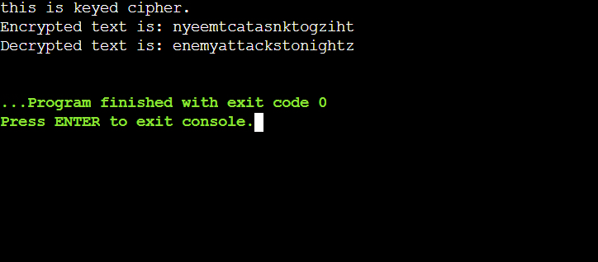

**KEYLESS**

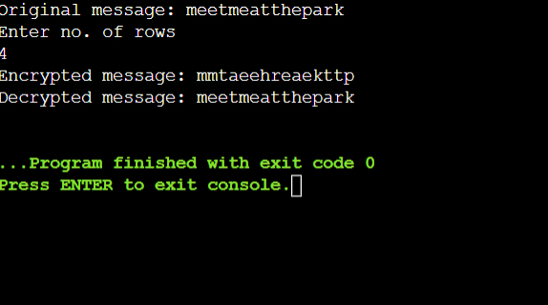

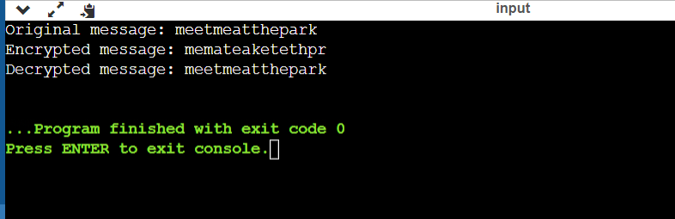

**DOUBLE TRANSPOSITION**

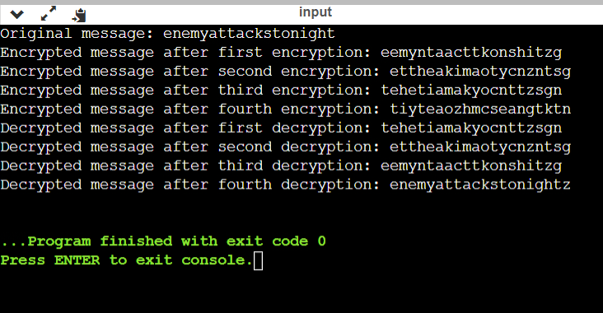

**COMBINED TRANSPOSITION**

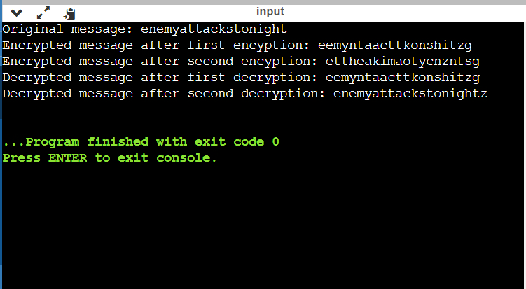

**RSA**

